Project Plan

< Victoria State Accident Analyzing Tool>

s5305407 Sunwoo Nam

s5316065 Ze Zeng

s5319113 Yunshuo Zhang

Table of Contents

1.0 Introduction 3

1.1 Problem Background 3

1.2 Scope 3

1.3 Document contents 3

2.0 Work Breakdown Structure 4

3.0 Activity Definition & Estimation 5

4.0 Gantt Chart 6

# Introduction

## Background

The Victoria State Accident Dataset is a large and complex dataset that contains information on road accidents that occurred in Victoria, Australia from 2015 to 2020. The dataset includes information on the type of accident, the location, the time of day, the weather conditions, and the number of injuries and fatalities. The dataset is a valuable resource for traffic engineers, urban planners, and other stakeholders who are responsible for improving road safety. However, the sheer size and complexity of the dataset make it difficult to extract meaningful insights from it. This project aims to develop a software solution that will make it easier to analyse the Victoria State Accident Dataset. The software will provide users with a variety of tools for data cleaning, data mining, and data visualization. This will allow users to identify patterns and trends in the data that would be difficult to see by simply looking at the raw data.

## Scope

The project's scope is comprehensive and designed to meet a range of essential requirements. At its core, the project will design, develop, and deploy a specialized software tool tailored to analyse the Victoria State Accident Dataset. The software will feature an intuitive user interface to ensure ease of use for a diverse user base, ranging from traffic engineers to local authorities. Robust data filtering tools will be incorporated to allow users to sift through the extensive dataset effectively, focusing on specific variables like regions, accident types, and time frames. Additionally, the software will offer a variety of data visualization options, including heatmaps, line graphs, and bar charts, to facilitate better understanding and interpretation of the data. Lastly, predictive analysis capabilities will also be integrated, enabling stakeholders to forecast future accident trends and thereby engage in proactive planning. This comprehensive approach ensures that the software not only serves as an analytical tool but also as a decision-making platform for various stakeholders.

## Document contents

* **Project Plan.docx**: This document outlines the project's Introduction, Work Breakdown Structure, Activity Definition and Gantt Chart.
* **User Manual**.docx: A user manual providing instructions on how to use the software and showcasing its features with informative screenshots.
* **Software Testing Reports.docx**: A report containing a brief testing plan, unit tests, and coverage test results using the provided template.
* **Executive Summary**.docx: An executive summary covering a 12-month period, providing analysis and comments about the data using the provided template.
* **Gantt chart.xlsx**: A high-resolution Gantt chart illustrating the project timeline and milestones.
* **git_log.txt**: A copy of the Git Log to track version control and changes.
* **Software Design Document**.docx: A detailed document describing the software architecture, components, and data flow.

# Work Breakdown Structure

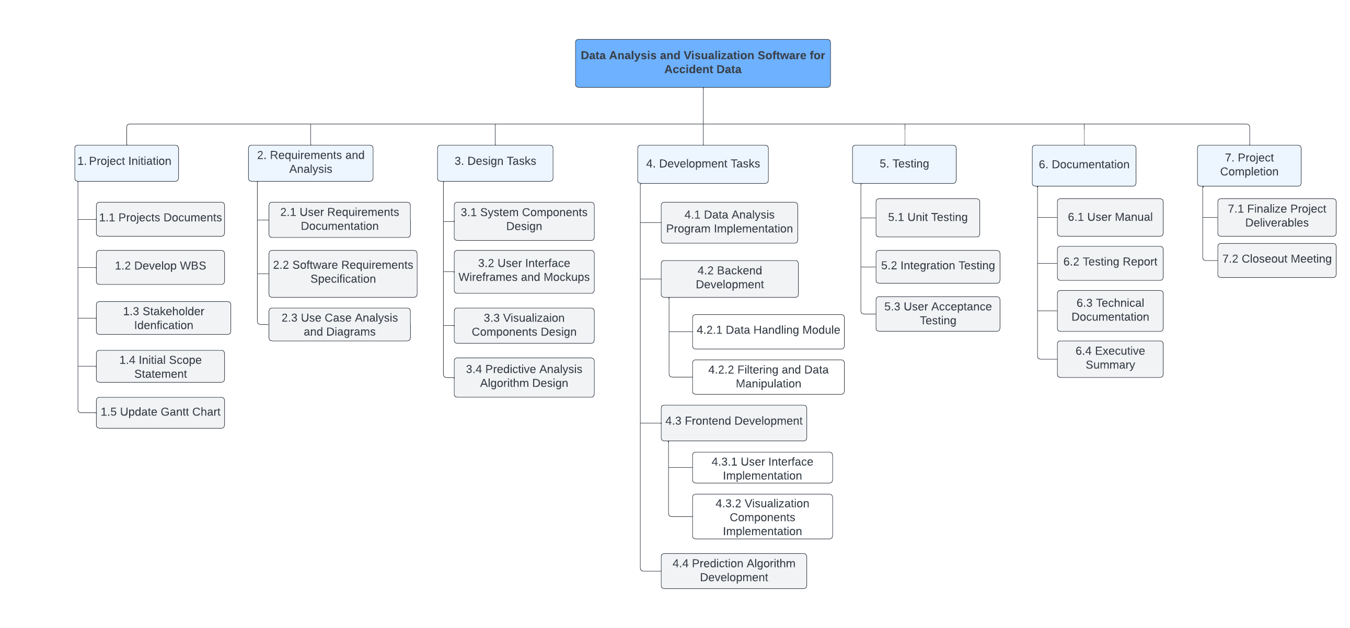

# Activity Definition & Estimation

|  |  |  |  |  |
| --- | --- | --- | --- | --- |
| **Task ID** | **Description** | **Effort** | **Resources** | **Predecessor** |
| Project Initiation | | | | |
| 1 | Develop Project Documents | 1 day | Project Manager, Business Analyst | 0 |
| 2 | Develop WBS | 2hrs | Project Manager, Project Team | 1 |
| 3 | Identify Stakeholders | 1hr | Project Manager, Project Team | 1 |
| 4 | Define Initial Scope Statement | 2hrs | Project Manager, Business Analyst | 1 |
| 5 | Update Gantt Chart | 1 hr | Project Manager, Project Team | 2 |
| Requirements and Analysis | | | | |
| 6 | Gather User Requirements | 1 hr | Business Analyst, Data Scientist | 3,4 |
| 7 | Document Software Requirements | 1 hr | Business Analyst, Software Architect | 5 |
| 8 | Create Use Case Diagrams | 1 hr | Business Analyst, UI/UX Designer | 5 |
| Design Tasks | | | | |
| 9 | Design System Components | 3 hrs | Software Architect, System Designer | 6,7 |
| 10 | Develop User Interface Wireframes | 3 hrs | UI/UX Designer | 8 |
| 11 | Design Visualization Components | 3 hrs | UI/UX Designer, Data Analyst | 8 |
| 12 | Design Predictive Analysis Algorithm | 2 hrs | Datta Analyst, Software Developer | 8 |
| Development Task | | | | |
| 13 | Implement Data Analysis Program | 1hr | Software Developer, Data Analyst | 9,10,11,12 |
| 14 | Backend: Develop Data Handling Module | 4 hrs | Software Developer, Data Analyst | 10 |
| 15 | Backend: Implement Data Filtering | 4 hrs | Software Developer, Data Analyst | 12 |
| 16 | Frontend:  Implement User Interface | 3 hrs | Software Developer, UI/UX Designer | 14 |
| 17 | Frontend: Develop Visualization Components | 3 hrs | Software Developer, Data Analyst | 10 |
| 18 | Develop Prediction Algorithm | 1 day | Data Scientist, Data Analyst | 14,16 |
| Testing Tasks | | | | |
| 19 | Conduct Unit Testing | 2 hrs | QA Testers, Software Developer | 13,14,15,16,17,18 |
| 20 | Perform Integration Testing | 2 hrs | QA Testers, Software Developer | 18 |
| 21 | User Acceptance Testing (UAT) | 2 hrs | QA Tester, Project Manager | 19 |
| Documentation | | | | |
| 22 | Create User Manual | 3 hrs | UI/UX Designer | 10 |
| 23 | Generate Testing Report | 2 hrs | QA Tester | 22 |
| 24 | Prepare Technical Documentation | 2 hrs | Software Architect | 23 |
| 25 | Prepare Executive Summary | 2 hrs | Data Analyst | 24 |
| Project Completion | | | | |
| 26 | Finalize Project Deliverables | 2 hrs | Project Manager | 25 |
| 27 | Closeout Meeting | 1 hr | Project Manager, Project Team | 26 |

# Gantt Chart

